|  |
| --- |
| **Invitation package to** |
| World Archery Europe. European Target Championships 2018 |
| **Legnica (Poland) August 27 – September 01 2018** |



|  |
| --- |
|  |

**Invitation**

TO ALL THE WORLD ARCHERY EUROPE MEMBER ASSOCIATIONS

Dear President

On behalf of the Local Organizing Committee of the 2018 European Championship, we would like to invite your Association to the city of Legnica, Poland from 27th August to 1st September 2018, to be part to the 2018 European Championships. That event is also valid as Qualifying Tournament for the 2018 European Games in Minsk, Belarus.

The city of Legnica is in south-western Poland in the centre of the Lower Silesia. It has over 100 thousands citizens, which makes Legnica the third most populated city of the region. Legnica plays an important role in economy, culture and science of the region.

Please find enclosed the necessary documents of registration, organization and participation for this event. Please, complete your registration in WAREOS before the deadlines:

Summary of deadlines:

* **Preliminary Entries 29 May 2018**
* **Preliminary Hotel Reservation form & 50% deposit 18 June 2018**
* **Preliminary Transportation Form 18 June 2018**
* **Visa Support Form 18 June 2018**
* **Final Hotel & Transport Form with Remaining Balance 23 July 2018**
* **Final Entries on WAREOS 3 August 2018**

Looking forward to welcoming you in Legnica, Poland.

Sincerely yours,

Mr Józef BAŚCIUK

President of Local Organizing Committee

|  |  |  |
| --- | --- | --- |
| **European Championships 2018**  **Preliminary Programme** | | |
| *26 Aug 2018*  *Sunday* | *Unofficial Practice*  *WAE Elective Congress* | *Municipal Stadium,*  *City Park*  *The Knight Academy* |
| *27 Aug 2018*  *Monday* | *Official Practice – Equipment Inspection*  *Team Managers Meeting*  *Opening Ceremony* | *Municipal Stadium,*  *City Park*  *Old Market Square* |
| *28 Aug 2018*  *Tuesday* | *Qualification Rounds*  *Recurve and Compound* | *Municipal Stadium,*  *City Park* |
| *29 Aug 2018*  *Wednesday* | *Individual Eliminations*  *Team Eliminations*  *Recurve and Compound* | *Municipal Stadium,*  *City Park* |
| *30 Aug 2018*  *Thursday* | *Individual Eliminations*  *Recurve and Compound*  *Mixed Team Eliminations* | *Municipal Stadium,*  *City Park* |
| *31 Aug 2018*  *Friday* | *European Games Qualifying Tournament*  *Recurve & Compound* | *Municipal Stadium,*  *City Park* |
| *01 Sep 2018*  *Saturday* | *Compound & Recurve Finals*  *Individual / Team & Mixed Team* | *Old Market Square* |
| *02 Sep 2018*  *Sunday* | *Departure of teams* | *Hotels* |
|  |  |  |

*Note: This is a preliminary programme and subject to change according to the number of participants and special requirements. All changes will be published and distribute in advance.*

*Website:* [*www.archery-legnica.pl*](http://www.archery-legnica.pl) *Contact Email:* [office@archery-legnica.pl](mailto:office@archery-legnica.pl)

**Preliminary & Final Registration**

No entry forms will be available to register for this event: the registration process must be completed using WAREOS.

Member Associations can login to WAREOS at [http://register.worldarchery.org](http://register.worldarchery.org/) with the username and password assigned by World Archery. After entering WAREOS, selecting the event from the list will allow a member association to register their athletes. Select/press the “Entries” button to see the list of categories in the event. Select/press the “category” to enter the athlete and official numbers/details participating for that event. A *WAREOS User Manual* can be downloaded in PDF format (English) upon login.

Contact Mr. JK LEE ([jklee@archery.org](mailto:jklee@archery.org)) in the World Archery Office with any questions regarding WAREOS.

A maximum number of **three (3) athletes per country** can be registered into each category and division of the event.

* **Starting date of on-line registration with WAREOS: 26 February 2018**
* **End of preliminary registration using WAREOS: 29 May 2018**
* **End of final registration using WAREOS: 3 August 2018**

Please respect the stated deadlines.

Member Associations can only use WAREOS to make any changes or amendments to entries and will be able to do so at any time. An email will automatically notify the Organizing Committee/Member Association of any changes made in WAREOS.

Any changes that are made after the deadlines specified or if entries differ by more than 4 athletes from the preliminary entries, the following penalty fees will automatically be applied: 140,00 € per entry.

Failure to have made preliminary entries before the deadline but then submitting final entries will result in a penalty fee of 140,00 € per entry to be paid to the LOC.

Any entries received less than 3 days before the team managers meeting will be refused if no preliminary entry and/or final entry are made prior.

As a final note, only member Associations in good standing will be eligible to compete. This means that World Archery fee must have been paid prior the participation.

**ADDITIONAL INFORMATION**

**Entry Fees**

* Individual: €150 per Archer
* Team: €75 per Team
* Official: €50 per Official

There is no entry fee for participation in the Mixed Team event and/or in the Olympic European Continental Qualifying Tournament***.***

Entry fees include daily local transport to and from the practice and competition fields to/from the official hotels from Sunday 26th August to Saturday 1st September (transportation timetables to be confirmed onsite).

**Non-official hotels**

Participants who book their accommodation in non-official hotels will have to pay double entry fee, and the LOC is not responsible to provide any transportation or meals from NON-Official Hotels. In addition, no information will be distributed to the nonofficial hotels. Furthermore, they have to register at accreditation no later than the day before the official practice. If they do not register the day before, no changes will be made to the entry list and it is likely that they will not be allowed to compete.

**Venues**

**Please note that car parking will be available at the venues.**

**Practice Venue**

The practice venue will be available from 26th to 31st Aug and is located at the following address:  
17 Radosna Street, 59-220 Legnica.  
Local transportation will be available. Timetables will follow.

**Qualification Venue**

The qualification venue are located at the Municipal Football Stadium in the City Park, at the following address: 1 Aleja Orła Białego, 59-220 Legnica

**Finals Venue**

The Finals venue is located at Old Market Square in the centre of Legnica.

The below map shows the location of the venues and official hotels for this event.

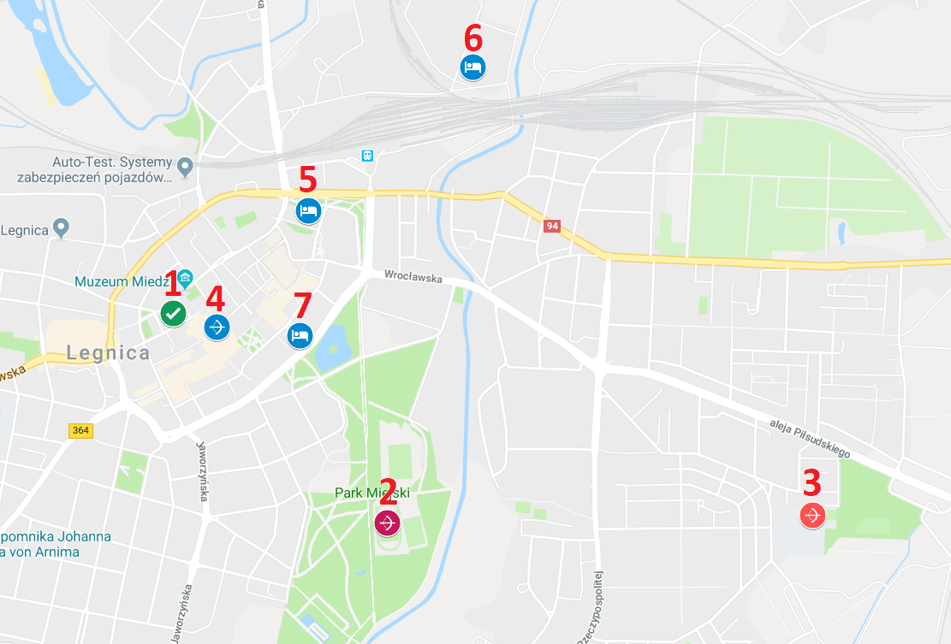

1. **Elective Congress Venue - The Knight Academy**
2. **Qualification & elimination Venue – Municipal Football Stadium**
3. **Practice Venue**
4. **Opening Ceremony & Finals Venue – Old Market Square**
5. **Qubus Hotel 4* – Event Office/ Accreditation Centre**
6. **Sękowski Hotel 3\***
7. **Kamieniczka Hotel 3\***

**Accommodation**

Hotel reservations will be allocated on a first come First serve basis.

* **Preliminary hotel reservations need to be made before: 18 June 2018**
* **Final hotel reservations need to be made before: 23 July 2018**Reservations after these dates will be subject to availability.

The official hotels are, Qubus 4*, Sękowski 3* and Kamieniczka 3*. Room rates are based on per person per night, VAT and full board included. All Member Associations are required to submit the preliminary hotel reservation form before 18 June 2018. Booking will only be valid once a 50% deposit has been received by the LOC before 18 June 2018. Full payments are to be made before 23 July 2018. Reservations after these dates will be subject to availability.  
Please ensure all the necessary forms are completed by the specified dates. All payments are to be made within the stated deadlines:

**Hotels**

**Room Rate for all hotels are *per person* per night and include, Breakfast, Lunch and Dinner**

# Qubus Hotel 4*

**Qubus Hotel is located 1 km, 5 minutes (driving) and 10 minutes walking to the qualification venue.**

**For additional hotel information please refer to** [www.archery-legnica.pl/hotels/](http://www.archery-legnica.pl/hotels/)

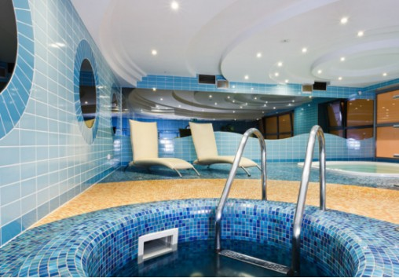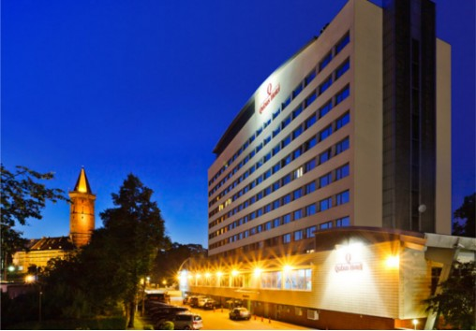

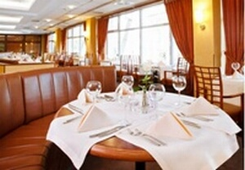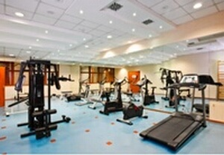

|  |  |  |  |
| --- | --- | --- | --- |
| **RATES PER PERSON PER NIGHT** | | | |
| **Single Room** | | **€110.00** | |
| **Twin / Double Room** | | **€90.00 (per person)** | |
| **TRIPLE ROOM** | | **€80.00 (per person)** | |
|  |  | |

# Sękowski Hotel 3*

**Sękowski Hotel is located 2 km, 10 minutes (driving) and 20 minutes travel time (walking) to the qualification.**

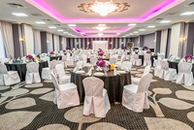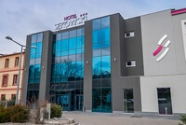**For more hotel information please refer to** [www.archery-legnica.pl/hotels/](http://www.archery-legnica.pl/hotels/)

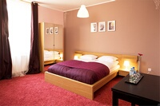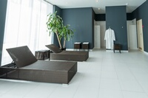

|  |  |
| --- | --- |
| **RATES PER PERSON PER NIGHT** | |
| **Single Room** | **€95.00** |
| **Twin / Double Room** | **€85.00 (per person)** |
| **TRIPLE ROOM** | **€70.00 (per person)** |

# ~~Kamieniczka Hotel 3~~*not available

**Kamieniczka Hotel is located 1 km, 5 minutes (driving) and 10 minutes travel time (walking) to the qualification.**

**For more hotel information please refer to** [www.archery-legnica.pl/hotels/](http://www.archery-legnica.pl/hotels/)

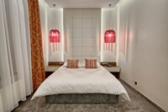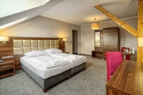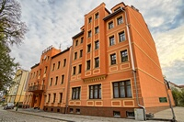

|  |  |
| --- | --- |
| **RATES PER PERSON PER NIGHT** | |
| **Single Room** | **€95.00** |
| **Twin / Double Room** | **€85.00 (per person)** |
| **TRIPLE ROOM** | **€70.00 (per person)** |

**Catering**

Breakfast and dinner will be served at the hotels. Lunch will be a two courses meal lunch served at the venue.

**Transportation**

Transportation to and from the venue will only be provided for participants accommodated within the official hotels and booked through the LOC. No information will be distributed outside of official hotels.

* Transportation to and from the venues and the hotels is included in the entry fee
* Transportation to and from the airport is at the following additional price:
  + Wrocław International Airport (IATA: WRO, ICAO: EPWR) **€30 Per Person**

Wrocław Airport (<http://airport.wroclaw.pl/en/>) to Legnica is far approximately 75 km and 55 minute.

**Awards Ceremony**

Each country is requested to bring their National Flag (at least 200 x 100cm) and a CD of their country’s National Anthem. For all ceremonies dress code is obligatory.

**Closing Banquet**

The closing banquet will be held on 1st September 2018 at the Qubus hotel, snacks and a drink will be provided. Cost **€20 per person**.

**Dress Regulations**

World Archery and World Archery Europe dress regulations apply for this event.

**Visa**

For all nations needing visa permits, please make sure that you apply for as early as possible in your country of origin before leaving. If our help is needed you may contact us immediately on: office@archery-legnica.pl. For official invitations please apply before 18 June 2018 on the form provided with copies of passports attached.

**Please Note: Visas are the responsibility of the individual nations and not the Organising Committee.**

**Weather**

According to weather information, the average daily temperature for end of August and beginning of September is 18-27 Celsius. Please note that the temperature will drop in the evening, rain is possible.

**Training**A training field will be available from 09:00 of 26 August 2018. This is located at the 17 Radosna Street venue and transportation will be provided from official hotels.

**Accreditation**

Accreditation will take place at the Qubus Hotel on 25 / 26 / 27 Aug 2018. The address of the hotel is: 2 Skarbowa Steet, 59-220 Legnica.

**Team Managers Meeting**

More details will be provided at the team managers meeting on 27 August 2018 in the Conference room at Municipal Football Stadium (Qualification Venue), from 12:00 to 13:00.

**Insurance**

Teams are expected to have their own personal travel, equipment and belongings insurance. Event insurance will be in accordance with World Archery rules and regulations.

**Internet**

Wi-fi will be available in all event hotels free of charge.

**Payment Instructions:**

All payments are to be made in Euros by bank transfer to:

BANK: RAIFFEISEN Bank Polska SA  
BRANCH ADDRESS: ul. Grzybowska 78, 00-844 Warszawa, Poland  
BANK ACCOUNT HOLDER NAME: OSL Strzelec  
BANK ACCOUNT HOLDER ADDRESS: ul. Gornicza 9, 59-220 Legnica, Poland  
SWIFT CODE: RCBWPLPW  
ACCOUNT NO: PL 28 2340 0009 0901 2460 0000 0010

* We regret that credit cards and travellers’ cheques will not be accepted.
* Bank Transfer fees are the responsibility of the sender
* Entry and accommodation fees must be paid in full BEFORE arrival

**Cancellations & Changes**

Cancellation must be made by email to **[office@archery-legnica.pl](mailto:office@archery-legnica.pl)** and be received before 18 June 2018 for a complete refund of the deposit paid. Refunds will be processed after the event

Any entries received after this date will not be eligible for a refund.  
All rates for payments after deadlines are subject to additional changes without prior notice.

**World Archery Europe Congress**

World Archery Europe Congress will be held on 26 Aug 2018. All information will be provided in advance to the Member Associations.

**European Games 2019 Qualifying Tournament**

The QT will take place on 31 August 2018 at Qualification Venue for both recurve & compound athletes.

**Legnica: City Information**

Legnica, located in the centre of the Lower Silesia has over 100 thousands citizens, which makes Legnica the third most populated city in the Lower Silesia voivodeship. Convenient location in the centre of the region influences on fast and wide-ranging development. Legnica plays important role in economy, culture and science of the region. Rich, complicated history and multicultural tradition make Legnica the second important city of the Lower Silesia region.

Liegnitz, Lignica are former names of the city. The Piast dynasty had ruled the city for over 500 years. Legnica and the region were reigned also by Bohemian Crown, the Habsburgs Dynasty, Kingdom of Prussia and Germany. Legnica witnessed important battles, which could have changed the history of Europe. Invasion of Mongolian army, heading westward, was repulsed in 1241. Thereafter, Frideric’s II Prussian army defeated Austrian army in 1760 and Marshal Blücher’s army stopped Napoleon’s army in 1813. In the modern history, Legnica was base for Red Army. The city is known today as “little Moscow”. One of legends connected with Red Army was filmed by Waldemar Krzystek. The film was awarded in Polish Film Festival in Gdynia.

Architecture of the city is the best proof of its rich history. A visitor to Legnica can’t miss Piast Castle, Cathedral and Saint Mary Church, which are the greatest examples of prosperity of Legnica in the Middle Ages. Baroque brought magnificent Jesuit’s complex with Saint John Church, Piast’s mausoleum and Knights Academy. Due to number parks and green grounds, founded in XIX. century, Legnica was called the City of Platans and Parks.

The city, as important economic centre, places emphasis on heterogeneous branches of industry. Creation of Legnica Special Economic Zone attracted investors from variety of branches: heavy metals, chemistry, furniture manufacturers, machines, plastics, car parts and food. Proximity of KGHM Polska Miedź S.A. and LETIA Technology Park influences growth of Legnica and helps the city to develop modern technologies and supports scientific value of the region. Recent years brought dynamic development of the city and large scale investments, such as West City Ring, new surface of the Square Market and, being currently decorated, Knights Academy baroque complex.

Investments are supported by intellectual potential of young citizens of Legnica. The city is supraregional education centre, where over 10 thousand students graduate every year.

Legnica is famous for interesting artistic and cultural events, schedule of local, national and international events is ample. The most important are: Satyrykon-Legnica, Jewellery Festival, National Choirs Contest “Cantat”, European Colloquiums of Ethnic Minorities “Pod Kyczerą”. Celebration of Saint Mary’s Street name day and Push-Off of Makeshift Boats are major celebratory days for Legnica citizens and incoming guests.

Investing in sports and development of physical culture is one of the priorities in Legnica. A number of multipurpose sports fields and gymnasiums were built in the recent years. The major investment, City Stadium along with its side fields are the event venue for European Grand Prix 1st Leg in 2017.

# Preliminary Hotel Form:

|  |  |
| --- | --- |
| **Federation/Country:** | |
| **Contact Name:** | |
| **Contact Email:** | |
| **Telephone:** | Fax: |

***Transportation***

Arrival by Car Arrival by Airplane

***Accommodation***

|  |  |  |  |  |  |
| --- | --- | --- | --- | --- | --- |
| Hotel Name: ……………………………………………………………. | | | | | |
| Room Type | **Rate - PPPN** | **No of Rooms** | **Arrival Date** | **Departure Date** | **Number of Nights** |
| **Single** |  |  |  |  |  |
| **Twin / Double** |  |  |  |  |  |

Any Special Instructions……………………………………………………………………………………………………….

…………………………………………………………………………………………………………………………………………….

PLEASE:

Return the form to the OC before 18 June 2018 email to [office@archery-legnica.pl](mailto:office@archery-legnica.pl)

*Signature of President/Secretary General: ____________________________________*

*Date:______________________________________*

# Transportation Form

|  |  |
| --- | --- |
| **Federation/Country:** | |
| **Contact Name:** | |
| **Contact Email:** | |
| **Telephone:** | Fax: |

Arrival by Car Date:…………………………… Estimated time of arrival:………………………………

Arrival by Airplane

***Arrival Flight***

|  |  |
| --- | --- |
| **Number of Passengers:** | **Arrival Airport:** |
| **Airline:** | Flight Number : |
| **Date:** | Arrival Time: |

***Departure Flight***

|  |  |
| --- | --- |
| **Number of Passengers:** | **Arrival Airport:** |
| **Airline:** | Flight Number : |
| **Date:** | Departure Time: |

Any Special Instructions………………………………………………………………………………………………………….

……………………………………………………………………………………………………………………………………………….

PLEASE:

Return the form to the OC before 18 June 2018 email to [office@archery-legnica.pl](mailto:office@archery-legnica.pl)

*Signature of President/Secretary General: ____________________________________*

*Date:______________________________________*

# Final Entry Forms

|  |  |
| --- | --- |
| **Federation/Country:** | |
| **Contact Name:** | |
| **Contact Email:** | |
| **Telephone:** | Fax: |

***Transportation***

Arrival by Car Arrival by Airplane

***Accommodation***

|  |  |  |  |  |  |
| --- | --- | --- | --- | --- | --- |
| Hotel Name:…………………………………………………….. | | | | | |
| Room Type | **Rate - PPPN** | **No of Rooms** | **Arrival Date** | **Departure Date** | **Number of Nights** |
| **Single** |  |  |  |  |  |
| **Twin / Double** |  |  |  |  |  |

***Arrival Flight***

|  |  |
| --- | --- |
| **Number of Passengers:** | **Arrival Airport:** |
| **Airline:** | Flight Number: |
| **Date:** | Arrival Time: |

***Departure Flight***

|  |  |
| --- | --- |
| **Number of Passengers:** | **Arrival Airport:** |
| **Airline:** | Flight Number: |
| **Date:** | Departure Time: |

Any Special Instructions / Dietary Requirements / Disability Team Members:………………….….

……………………………………………………………………………………………………………………………………………….

……………………………………………………………………………………………………………………………………………….

PLEASE:

Return the form to the OC before 23 July 2018 email to [office@archery-legnica.pl](mailto:office@archery-legnica.pl)

*Signature of President/Secretary General: ________________________________*

*Date:___________________*

# Budget Form

1. ***Entry Fee***

|  |  |  |  |  |
| --- | --- | --- | --- | --- |
| Position | **No. of persons** | **No. of persons** | **Cost** | **Total** |
| **Athlete** |  |  | €150 | € |
| **Official** |  |  | €50 | € |
| **Team** |  |  | €75 | € |
|  |  |  | Total 1 | € |

1. ***Accommodation***

|  |  |  |  |  |
| --- | --- | --- | --- | --- |
| **Hotel:…………………………………………………………………….** | | | | |
| **Room** | No. of Nights | No. of People | Cost | Total |
| **Single** |  |  | € | € |
| **Twin/Double** |  |  | € | € |
|  |  |  | Total 2 | € |

1. ***Transport***

|  |  |  |  |
| --- | --- | --- | --- |
| **Airport** | **Cost Per Person** | **No. of Passengers** | **Total** |
| **Wrocław Airport** | €30 |  |  |
|  |  | Total 3 | € |

1. ***Closing Banquet***

|  |  |  |  |
| --- | --- | --- | --- |
| **Banquet** | **No. of Persons** | **Costs** | **Total** |
|  |  | Rate €20 |  |
|  |  | Total 4 | € |

*Total (1+2+3+4)* €*_____________________*

*Signature of President/Secretary General: ____________________________________*

*Date:______________________________________*

PLEASE:

Return the form to the OC before 23 July 2018 email to [office@archery-legnica.pl](mailto:office@archery-legnica.pl)

# Rooming List

|  |  |
| --- | --- |
| **Federation/Country:** | |
| **Contact Name:** | |
| **Contact Email:** | |
| **Telephone:** | Fax: |

|  |  |  |  |
| --- | --- | --- | --- |
|  | **Room Type** | **Guest** | **Guest** |
| **1** |  |  |  |
| **2** |  |  |  |
| **3** |  |  |  |
| **4** |  |  |  |
| **5** |  |  |  |
| **6** |  |  |  |
| **7** |  |  |  |
| **8** |  |  |  |
| **9** |  |  |  |
| **10** |  |  |  |
| **11** |  |  |  |
| **12** |  |  |  |
| **13** |  |  |  |
| **14** |  |  |  |
| **15** |  |  |  |
| **16** |  |  |  |
| **17** |  |  |  |
| **18** |  |  |  |
| **19** |  |  |  |
| **20** |  |  |  |

PLEASE:

Return the form to the OC before 23 July 2018 email to [office@archery-legnica.pl](mailto:office@archery-legnica.pl)

# Visa Support Form

|  |  |
| --- | --- |
| **Federation/Country:** | |
| **Contact Name:** | |
| **Contact Email:** | |
| **Telephone:** | Fax: |

|  |  |  |  |  |  |  |  |
| --- | --- | --- | --- | --- | --- | --- | --- |
| **Given Name** | **Family Name** | **Date of Birth** | **Passport Number** | **Date of Issue** | **Date of Expiry** | **Country of Issue** | **Athlete or official** |
|  |  |  |  |  |  |  |  |
|  |  |  |  |  |  |  |  |
|  |  |  |  |  |  |  |  |
|  |  |  |  |  |  |  |  |
|  |  |  |  |  |  |  |  |
|  |  |  |  |  |  |  |  |
|  |  |  |  |  |  |  |  |
|  |  |  |  |  |  |  |  |
|  |  |  |  |  |  |  |  |
|  |  |  |  |  |  |  |  |
|  |  |  |  |  |  |  |  |
|  |  |  |  |  |  |  |  |
|  |  |  |  |  |  |  |  |
|  |  |  |  |  |  |  |  |

*Signature of President/Secretary General: ____________________________________*

*Date:______________________________________*

PLEASE:

Return the form to the OC before 18 June 2018 email to [office@archery-legnica.pl](mailto:office@archery-legnica.pl)

**Please ensure to forward copies of valid passports**